**Project: ADV Job Portal**

2021

M Umer Mukhtiar (Leader) SP20-BSE-055 Usman Toufiqe SP20-BSE-046 Noor Ahmed SP20-BSE-049

**Object Oriented Software Engineering**

Windows User

## Proposal

## Introduction

An Advanced Job Portal or Recruitment App which enable the users to upload and manage their works and skills related to their field of interest and for the employment they seek for future. The managed profile or digital CV can be a real game changing for the people with skills and having no platform to showcase their skills and works related to field.

Recruitment App will give the Employers an easy way to recruit best members and employers for their organization or company, as this app provides them with the work details and proofs of their work in the required field.

Employers who are recruiting the candidates can access the profile and Documents of the user by opening the unique share link given by user to the employer.

The Total rating of the user or Employee will promote automatically with the system as by taking the overall feedbacks from the Employers who are reviewing the profile of candidate.

* **Modules of App:-**
* **User Management**

1. Register on App with Sign up Form.
2. After Sign up Login into the App with login credentials.
3. In case of Forgot Password a small system for password recovery by email with a friendly button.
4. Edit User Profile in App.

* **Dashboard or Contents Management**

1. Dashboard will have the complete overview of the User with Progress of Profile
2. The Documents section will be available in Dashboard
3. The Multimedia Items with their Upload option will be here.

* **Menu**

1. Overall main functionalities of portal are available there .
2. User can also view any other user profile through code shared by user.
3. Here also a search option for employees and employers with detail profile

* **Feedback Panel**

1. Employee and employer both are able to give feedback on each other profiles.
2. Here also a option of feedback for suggestions about adding skills ,adding functionalities etc.

## Vision and Business Case

We Aim to make an Advanced platform for the all the people out there looking for work and employment.

Job Portal will have Organized Dashboard and Inventory system to manage and analyze the progress of each Users.

* **Business Opportunity: -**

Finding a Job is a Difficulty for today’s generation. As the existing Job portals and Recruitment apps does not give much control to the user to fully share and showcase their skills, This project will vary in that department by making more information and multimedia to upload for employees and candidates for getting the best job according to the talent they have.

**Summary of System Features:-**

## Supplementary Specification

1. Each page shall open within 1 second of tap on button and upload process with low latency with server.
2. The profile of each user shall be confidential and safe in system by his/her password and email.
3. The user demanding to increase storage space shall be given a monthly plan to upgrade their storage in system.
4. System shall be low end friendly which means it can be opened on any low end devices
5. The system will not damage or lose data of user if a crash happens as it operates with real time saving environment.
6. User shall not wait too long for a file to upload or download a file from server.
7. System shall not exceed the maximum storage provided to user for uploading documents and images.
8. User shall get a welcome message and a tutorial guide for the use of website after logging in to the system.
9. The website shall load in less than 2 seconds if the users profile’s data is less than 100Mbs.

## Risk List & Risk Management Plan

***Describes the risks (business, technical, resource, schedule) and ideas for their mitigation or response.***

**Risk List :**

* Usage of fake documents by employees.
* Copyright Issue on Shared content.
* Using Abusive Language in feedback .
* Privacy and security issues.
* Duplication of account.
* Inappropriate Feedback .
* Identification of scammers flash fraud.
* **Risk Management Plan :**

Accounts are verified by admins and in case of using fake documents and giving wrong information account should be banned by Admins. And After hiring or taking interview from any employee through portal Employer have option to give feedback against the employee hired from portal and if user have not fair feedbacks against their profile in that case profile is also banned .And user have also an option to give their feedback against employer profile and their company. And if any user can use abusive language in feedback account should be temporary ban and filters are used in backend to stop or put that feedback on pending until reviewed by admin and if someone try to spam in feedback account will be temporary ban and use of multimedia is allowed if user have permission and copyrights or have any proof that confirms content belongs to user directly or indirectly and one email or phone number will be used only for one account Duplication of account is not allowed.. And content user want to share with employer will be visible between user and employer and make sure data will be able to open through pin or system generated code .

**Project Prototypes**

* **User Management (SP20-BSE-055)**

**Login Section:**

<https://ibb.co/f21qz4d>

**Forgot Password:-**

<https://ibb.co/D4TW6hc>

**Sign Up :**

<https://ibb.co/9grC6rJ>

* **Menu**

**Menu:**

<https://ibb.co/khD8R9f>

------------------------------------------------------------------------------

## Contents Management(SP20-BSE-046)

### Dashboard Home and Overview:

<https://ibb.co/8xLrpXR>

### Documents Section:

<https://www.iloveimg.com/download/1d92vwc9t6jnkyvx1wb1Aph1A5c8j3x66mcmv5k0g5g2l8sr9t816dkk9Alvfd7t1dv43428r7rt974s9vk1v745zfr7zlywfvyb5t7vpyvn31hpq7rvAd037zcvn2kj2t5q0A1lgvczdc6clpq3nxlqy5zjn1yns79v2fqjrp727zrvxh6q/8>

### Videos Links:

<https://www.iloveimg.com/download/qtfjxrsmryj2qc9vq9rg235nl4vfjjvl64y9xbd0qsf5z2byh63w1nd9q7vt6nm988j0xbsh3s3l7xtjq3kgvzsvz30c22Aq5b5vbn2sjwdf28rlhltwps0pkzd5dmznmprd9r9fjlrbAkwb6mvx0pnd9km9qA5r0pnq6m3x35m82pq911fq/5>

------------------------------------------------------------------------------

* **Feedback Panel** (SP20-BSE-049)

**Select Category:**

<https://www.iloveimg.com/download/6j4Aslb01cA018q1dkfqzkj43v4fk13hw1j2xb9kkjr2x85bhx6d2d71q8A2p5rbjktnklbdlmfc9c0ds12qb6hArsyk6knkjr4Av54kbcmkb11159859lgdgndA9h5dbq5dcr2snl17ym6xjnlxkbpnA7pl6bjy59yw32c8ymAbc7xf8pAq/1>

**Give Feedback**:

<https://www.iloveimg.com/download/c38y8bk1wdhzsk9jwlj066ltnxzqk9jqc8rc6xk6rq51n0tt1p2b4sz9ygrv80qf08v003pz7qrr9730d4gmq1r9f08jlx45gy2pr9480gAt503c5nAv6yrqx18dnyys4nz2sn9cj4cjv88jg8h2q3sd1xcv6d9qlA2xc9f867d4tAzstyg1/8>

**Use Case Diagram:-**

**Primary Actors of Project:-**

1. **Employee/Candidate**
2. **Admin**
3. **Employer**

**Goals of Primary Actors:-**

**Candidate:-**

1. Login
2. Signup
3. Forgot Password
4. Upload docs
5. Upload Media Files
6. Set Profile
7. Share code to Profile
8. Select Skills
9. Report Profile

**Admin:-**

1. Login
2. Block User
3. Add Skills

**Employer:-**

1. Login
2. Signup
3. Forgot Password
4. Skill Feedback
5. User Profile Feedback
6. Set Profile
7. View Profile
8. Hire Employee
9. Report Profile

**Brief Level:- (**Muhammad Umer Mukhtiar **SP20-BSE-055)**

**1.Signup:-** Open App simply Go on the Login page and select the option of Signup and put correct information in empty fields . And some of text fields are compulsory to be filled and also be agree on terms and conditions by clicking on agree After accepting terms and conditions click on Signup And your account is created and user name and password will be previewed on screen.

**2.Forgot Password**:- User open the app and click on the Forgot password button and empty text field is appeared and Enter email or user name click on submit and security question is appeared answer that and after that user directly linked to the manage profile window to set their password again.

**3.Login:-**User open the app and login session was created and window appears at user end and ask for login Information(Username, password) in empty text fields and after filling text fields click on Login button and you’re greet with Dashboard Window.

**4.Set Profile:-** User open Portal greet with Login Screen And Fill the text fields with required information and click on login button and greet with Dashboard and select the option of set profile and from Here users can change their name and user can also change password and select new skills from here and also will be able to add bio data itself and after making changes simply click on save Changes.

**5.Select Skills:-**login to portal and click on set profile and select the skills from combo box and user can also select multiple skills from combo box and also write expertise in given skills in bio and also add other skills in bio after adding skills click on save changes. Skills are previewed on user profile.

**6.Hire Employee:-** login to portal and click on menu and write required skill at search bar and click on button all relevant user having employer required skill are shown at below the menu and from here user can click on user name profile should be appear in front of employer from here employer can click on select option to hire user .

**Brief Level:- (SP20-BSE-046)**

**1.Upload Document:-** A Candidate or user log ins to system and is provided with skills manage by admin and after completing profile User is given a Upload documents section, The user enters the location or path to the document and its format which are according to system needs and then system validates and shows the document on the profile of User.

**2.Generate Code:-** User Opens the profile menu and generate link button sends the system to link generation service and a random link is generated with URL and sharing option to other social media and copy to clipboard (Link is expired after 2 mins of generation).

**Brief Level(SP20-BSE-049)**

**1.GIVING FEEDBACK:-**Frist of all the employer will click the feedback section and enter the section. Then he will See the four columns. The first section is to write the overall feedback in second section he can write the unique skills of employee and then the third section will for the best skills of and then he can rate the user profile in fourth section and then he will click the submit button of feedback and we will use the filter in feedback section if someone uses the abusive language he cannot give feedback

**Fully Dressed :-**

**Login** (**Muhammad Umer Mukhtiar SP20-BSE-055)**

**Scope:-** Job Portal App

**Level:-** User Goal

**Primary Actor:-** Employee ,Employer , Admin

**Stakeholders and Interest:-**

-**Employee**:- Have Account to login.

**-Employer :-**Have Account to login.

-**Admin**:-Have Account to Login.

**Preconditions:-** open portal and enter login information .

**Success Guaranteed(Post):**- Login Session created And User Logged In Successfully.

|  |  |
| --- | --- |
| Main Success Scenario(Flow of events):- | Extensions(Alternative flows):- |
| Open Portal. |  |
| Login Session created |  |
| Enter Email or User Name. |  |
| Enter Password. | If User do unnecessary tries for Login and password account will be temporary banned. |
| Click On Login. | If User enter wrong email or user name system show dialog box with message to Enter Correct User Name and Password. |
| Dashboard tab will be opened |  |

**Special Requirements:-**

* Text fields
* Background colors
* Buttons

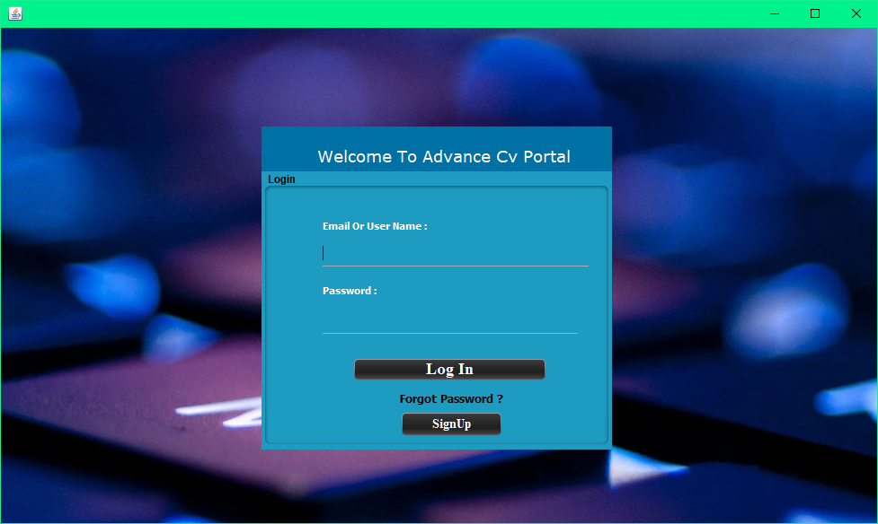

**Set Profile** (**Muhammad Umer Mukhtiar SP20-BSE-055)**

**Scope:-** Job Portal App

**Level:-** User Goal

**Primary Actor:-** Employee ,Employer

**Stakeholders and Interest:-**

-**Employee**:-

Have Account to Set Profile and add more information to show more attractive view of profile.

**-Employer :-**

Have Account to Set Profile and share info about required work.

**Preconditions:-**

give required Information in text Fields select options from combo boxes(Education , skills, country code) and upload profile picture .

**Success Guaranteed(Post):**-

Save changes Successfully and Profile Updated.

|  |  |
| --- | --- |
| Main Success Scenario(Flow of events):- | Extensions(Alternative flows):- |
| User Login |  |
| Greet with Dashboard. |  |
| Go to Menu |  |
| Click on Set Profile |  |
| Enter Required information in Text fields | * In case of giving wrong information or try to use fake name or less than 10 digit number dialog box appeared with warning. * if user do not give bio red text is appeared in text area. |
| Select right options from combo boxes. | * If user does not select country code dialog box will be appeared with warning. * If user do not select any skill dialog box appeared with warning. |
| Click on upload profile | * If user select more than 1 pic profile picture could not be changed. |
| Select picture and Upload. | * If any other format file or pic selected like pdf, docx etc. profile pic will not be changed |
| Click on save changes |  |
| Changes are applied on profile successfully | * If mandatory fields are empty dialog box appeared with message. |

**Special Requirements:-**

* Text fields
* Background colors
* Text area
* Buttons
* Combo boxes

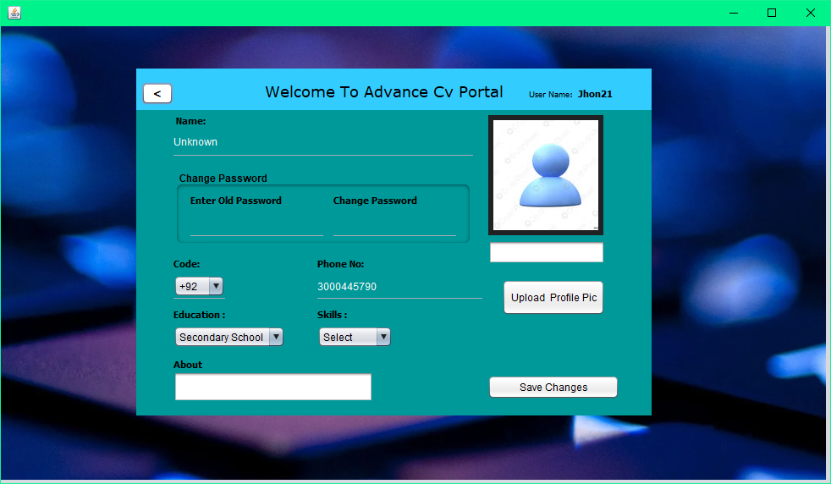**Sign Up** (Muhammad Umer Mukhtiar SP20-BSE-055)

**Scope:-** Job Portal App

**Level:-** User Goal

**Primary Actor:-** Employee

**Stakeholders and Interest:-**

-Employer:- It is necessary to create an account to use the portal.

-Employee:- It is necessary to create an account to use the portal for hiring employees.

-App:- Application requires the information to approve the account to register

**Preconditions:-**. Candidate will be required to give the information in order to create register account and maintain a public profile.

**Success Guaranteed(Post):**- After giving information it will be updated to user profile and will be save on public server .

|  |  |
| --- | --- |
| Main Success Scenario(Flow of events):- | Extensions(Alternative flows):- |
| Open Portal. |  |
| Click on Signup. |  |
| System Greets with Signup Window. |  |
| User fill the required fields | * If user want to use single email for multiple accounts dialog box will be shown with warning. * In case user given name is already existed suggestions of names will be shown. |
| Select the required options. |  |
| Accept terms And Conditions. | * If user not accept terms and conditions submit button will be disabled until user agree to terms and conditions. |
| Click on Submit . | * In case User miss to filled the mandatory text fields. Process could not be go forward and show red text in text fields until they will be filled. |
| Dialog Box Appeared with user name and password. |  |
| Click on Ok. |  |
| will be back to login screen. |  |

* **Special Requirements:-**
* Background Color
* 8 digit Password
* E-mail
* Accepting Terms and conditions.

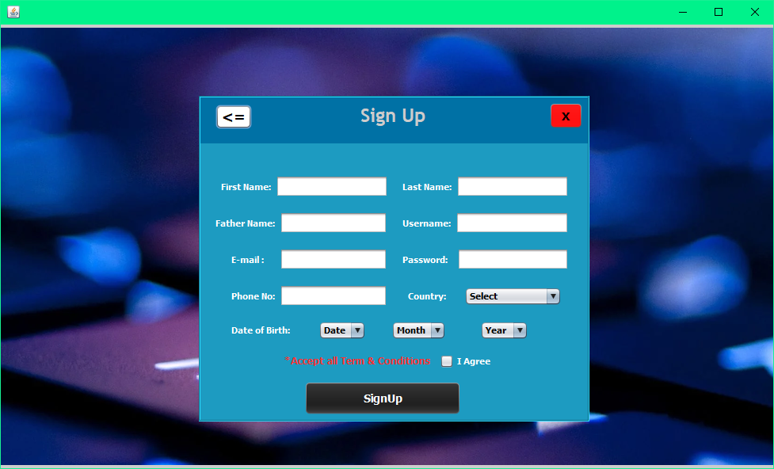

**Add Skills** (Muhammad Umer Mukhtiar SP20-BSE-055)

**Scope:-** Job Portal App

**Level:-** User Goal

**Primary Actor:-** Employee

**Stakeholders and Interest:-**

-**Employee**:- Add skills to profile making more attractive profile and easily .

**Preconditions:-** select skills from combo box or add skills in bio.

**Success Guaranteed(Post):**- Save changes Successfully and skills will be Updated on profile successfully.

|  |  |
| --- | --- |
| Main Success Scenario(Flow of events):- | Extensions(Alternative flows):- |
| User Login |  |
| Greet with Dashboard. |  |
| Go to Menu |  |
| Click on Set Profile |  |
| Select Skills from combo box . |  |
| Add more skills in bio. |  |
| Click on save changes. |  |
| Save Changes Successfully. | * if user do not select any skill dialog box is appeared with message. |

**Special Requirements:-**

* Text area
* Labels
* Buttons
* Combo boxes



**Forgot Password**(**Muhammad Umer Mukhtiar SP20-BSE-055)**

**Scope:-** Job Portal App

**Level:-** User Goal

**Primary Actor:-** Employee

**Stakeholders and Interest:-**

-**Employee**:- have user name or email to forgot password.

-**Admin**:- admin will temporary block users who will try to use of forgot password option to much.

**Preconditions:-**. User enter Username or email to forgot password.

**Success Guaranteed(Post):**- User is logged in and is informed that account password was successfully changed

|  |  |
| --- | --- |
| Main Success Scenario(Flow of events):- | Extensions(Alternative flows):- |
| Open Portal. |  |
| Go to Login. |  |
| Click on forgot password. | * If user do unnecessary tries for forgot password account will be temporary banned. |
| Enter Email or User Name. | * If text field was empty enter email message will be previewed . |
| Answer Security Question. | * If user answer was wrong account will be disabled. |
| Click On Submit. | * If User enter wrong email or user name system show dialog box with message to Enter Correct User Name and Password. |
| Manage profile tab will be opened. |  |
| Now enter your New Password. | * If password is less than 8 digits password will not be changed. |
| The system notifies user that the password was successfully changed |  |

**Special Requirements:-**

* Text fields
* Buttons
* Labels
* Frames

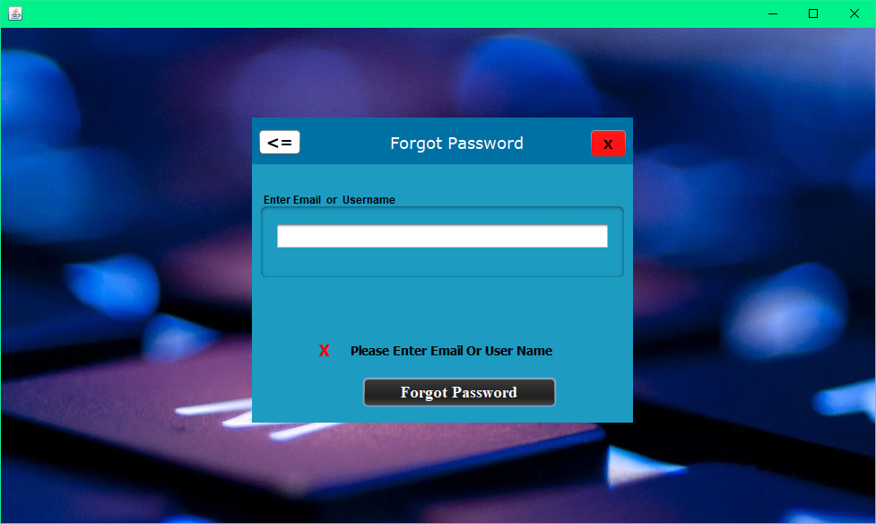

**Hire Employee** (Muhammad Umer Mukhtiar SP20-BSE-055)

**Scope:-** Job Portal App

**Level:-** User Goal

**Primary Actor:-** Employer

**Stakeholders and Interest:-**

-**Employer**:-hire employee for required work.

**Preconditions:-**enter required skill name in search bar.

|  |  |
| --- | --- |
| Main Success Scenario(Flow of events):- | Extensions(Alternative flows):- |
| User Login |  |
| Greet with Dashboard. |  |
| Go to Menu |  |
| Enter skill in search bar |  |
| Click on search button | * If no result found against skill dialog box appeared with message of no result found. |
| Click on employee name . |  |
| Profile previewed . |  |
| Click on Hire button. |  |
| Dialog box appeared with message “request forwarded successfully”. | * If user do not give any response in limited time request will be deleted. |

**Success Guaranteed(Post):**- show all employees according to search or relevant skill.

**Special Requirements:-**

* Labels
* Buttons
* Dialog box
* Frames.

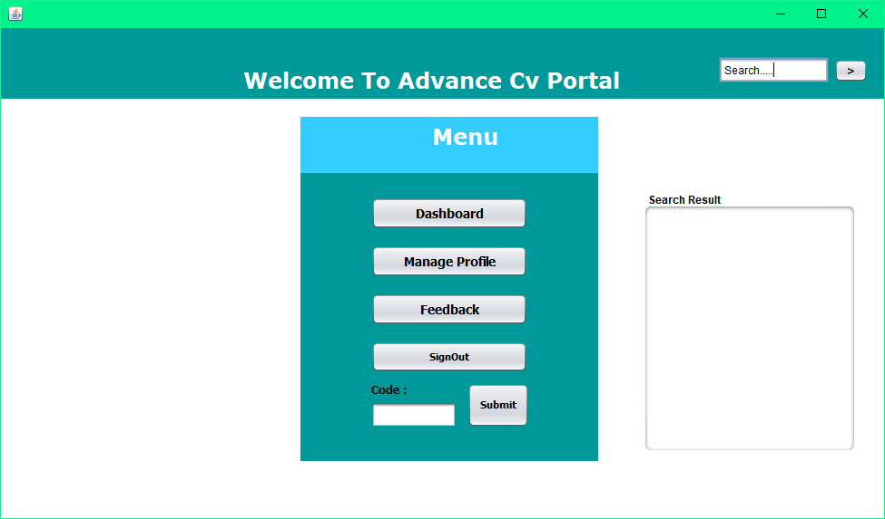

**+++++++++++++++++++++++++++++++++++++**

**1.Upload Document(Usman Taufique)**

**Scope:-** Job Portal App

**Level:-** User Goal

**Primary Actor:-** Candidate

**Stakeholders and Interest:-**

**-**Admin:- wants the documents to approve the profile and level up.

-Employer:- Needs to see the work and achievement of candidate to hire.

-App:- Application requires the educational data in documents to approve the profile to register

**Preconditions:-** Browse for document. Candidate will be required to upload the document in order to maintain a public profile.

**Success Guaranteed(Post):**- After uploading of documents it will be published to the public server of portal which can be shared to people of companies.

**Main Success Scenario(Flow of events):-**

1. User Logins
2. System Greets with dashboard
3. User selects the documents section
4. Click Upload Button
5. Upload Dialog appears
6. Selects Docx Files
7. Upload file or can select multiples
8. File is Uploaded and shown in documents section

**Extensions(Alternative flows):-**

1. In case User selects the file of other format than .docx or pdf file the system rejects the file and file is not uploaded.
2. User has to publish the document after uploading to profile to make it visible to the person reviewing the file.
3. If User cancel the upload it goes back to the Document section.

**Special Requirements:-**

-Docx or pdf file Requires

-File size not be greater than 2mb

-Documents needed with educational information and work experiences in file forms.

**2.Generate Share Code(Usman Taufique)**

**Scope:-Job Portal App**

**Level:- User Goal**

**Primary Actor:- Candidate**

**Stakeholders and interests:-**

-Candidate:- To share his work to public share code is needed

-Employer:- To hire someone and review profile the code is required to enter.

**Precondition:-** Someone want to see your data you just click on generate code and send generated link to person or company who wants .

**Success Guarantee(Post):**- After sending link to company or person

They are able to see your work experience and code is useful for 1 time at 1 device and automatically expire after using 1 time within 24 hours.

**Main Success Scenario(Flow of Events):-**

1. User logins
2. User Clicks the share code button on dashboard.
3. Code is generated as password to cloud
4. Code copy option is visible
5. User sends the Code to employer
6. Employer can use the Code to review profile or Hire.
7. Code is expired after 2 mins of generation.

**Extensions(Alternative Flow):-**

1. Code not opened in 2 mins it expires and shows nothing on click.
2. Code cannot be opened more than one time for one employer.
3. If Employer does not open link it expires
4. New link is generated and old is destroyed if user generates a new one.

**Special Requirements:-**

-Code must be generated and then copied too in 2 mins.

-Copied Code should be a small URL.

-Two generated Code cannot be same.

-Employer gets only viewing access to profile by Code

**3.Upload Videos(Media):**

**Scope:-Job Portal App**

**Level:- User Goal**

**Primary Actor:- Candidate**

**Stakeholders and interests:-**

-Candidate:- To share links to work videos on cloud storage or streaming platform.

-Employer:- Making a good review of employers work the video is required to post good feedback.

**Precondition:-** Candidate login to the portal and makes his profile more unique and attracting by giving links to the videos of work he/she has done or experienced.

**Success Guarantee(Post):**- When Candidate uploads or posts the link to video on his profile it is visible to employer to whom he/she shares code with and can view his/her videos on site or cloud.

**Main Success Scenario(Flow of Events):-**

User logins

User Clicks the Videos Section button on dashboard.

Videos list with links appears on App.

Links are clickable and clicked by user to review.

Candidate can upload new ones with upload button at bottom.

Clicking upload button brings up the dialog box with text to enter link to video.

After saving the link is available on Videos section of Dashboard.

**Special Requirements:-**

-Video link must be a link to only video.

-Copied Link should be a small URL.

-Cannot upload Videos Directly to App.

-Employer gets only viewing access to videos.

**4.View Profile:**

**Scope:-Job Portal App**

**Level:- User Goal**

**Primary Actor:- Employer**

**Stakeholders and interests:-**

-Candidate:- To make custom changes to profile as putting more information and details about experiences and education to make him/her more unique in list.

-Employer:- Wants to hire someone for work and company then wants to search or view profile or that candidate on app.

**Precondition:-** Candidate sign ups for app and choses the category of profile he wants to develop on app for work and market.

**Success Guarantee(Post):**- Candidate sign ups and login to app and then profile editing section is shown to edit name birth date and profile image for specifying the credits and information about him/her and employer searches for profile by code shared with him and has viewing access to profile

**Main Success Scenario(Flow of Events):-**

User sign ups

User Makes a Custom profile with need information.

Custom Profile with unique code is registered to app.

Code is shared to employer and he logins.

Employer after typing code clicks view profile.

The manage profile of user is displayed with relevant information to Employer.

**Special Requirements:-**

-Profile must be completed before sharing.

-Profile can only be shared when information is fully registered.

-User cannot make two profiles with same account.

-Employer can only view the profile.

**1.** **GIVING FEEDBACK (NOOR AHMED)**

**Scope:-** Job Portal App

**Level:-** User Goal

**Primary Actor:-** EMPLOYEE

**Stakeholders and Interest:-**

**-**Admin:- will check the feedback and approve it

-Employer: - need to give feedback for user profile

-App: - Application requires the educational data in documents to approve the profile to register

**Preconditions: -** Give the feedback

**Success Guaranteed (Post):**- after giving the feedback if the section says feedback is uploaded successfully uploaded.

**Main Success Scenario (Flow of events):-**

1. Employer open feedback section
2. Feedback section will appear
3. Employer will rate the skills
4. Give feedback in dialog box
5. Submit the feedback
6. Admin will approve the feedback
7. Feedback will be visible

**Extensions (Alternative flows):-**

1. In case if employer will use the abusive language, the feedback will automatically be rejected
2. Employer have to wait till the admin will approve the feedback
3. If employer cancel the feedback it will not visible to any one

**Special Requirements: -**

-Feedback must be given by employee

-feedback should be in the limited words

**_______________________________________________________**

**2.REPORT PROFILE (NOOR AHMED)**

**Scope: -Job Portal App**

**Level: - User Goal**

**Primary Actor: - Employer**

**Stakeholders and interests: -**

**Candidate**: - To share his work to public link is needed

**-Employer**: - report the fake profile or the fake user

**Precondition: -** employer must have dispute to report the profile

**Success Guarantee (Post):** - after the report will be review by the admin account will be terminated

**Main Success Scenario (Flow of Events): -**

1. Report profile
2. Click the report button
3. Dialog box will be appeared
4. Report the profile by different conditions
5. Then submitted the report
6. After the report it admin will approve it

**Extensions (Alternative Flow): -**

1. If once report is submitted it cannot be changed
2. If the report if wrong your profile will be terminated

**________________________________________________________**

**Domain Model**

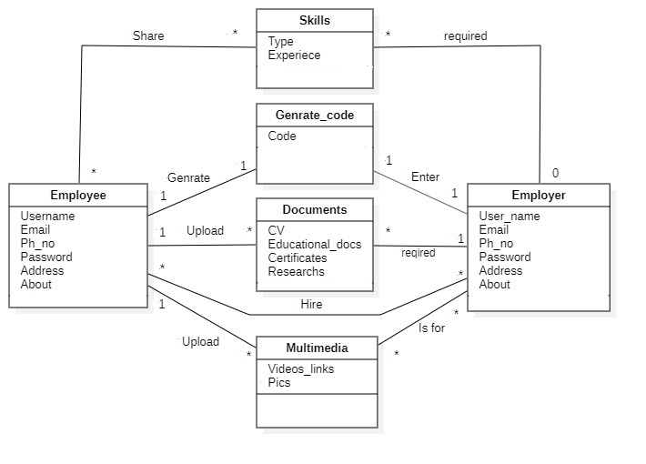

____________________________________________________

* **SSDs**

**Login**

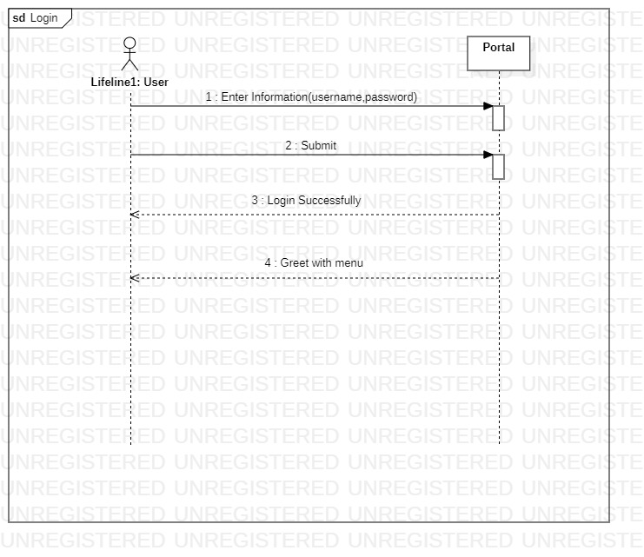

**Signup**

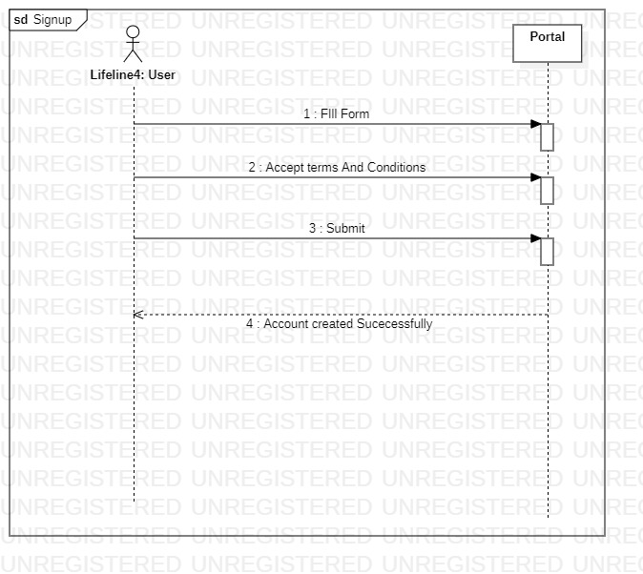

**Forgot:-**

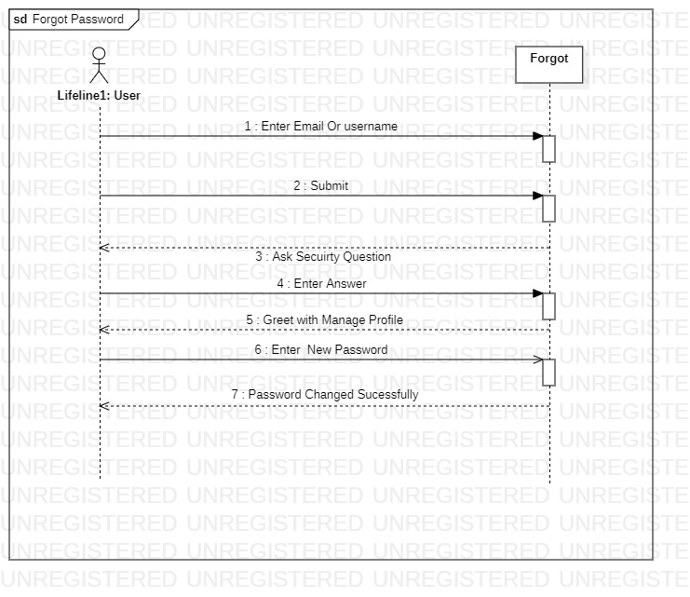

2021